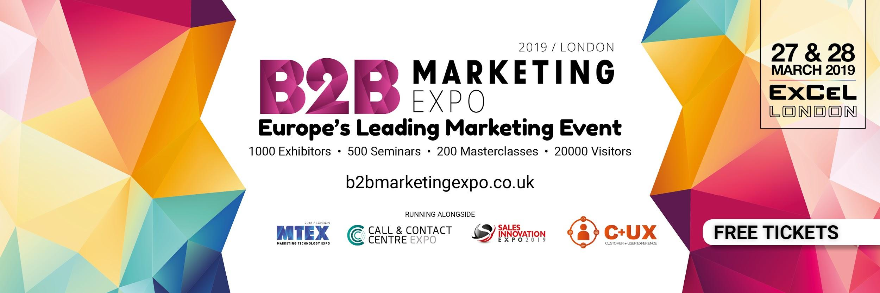
…………………………………………………………………………………………………………...

We can’t believe it but the B2B Marketing Expo will be opening its doors at the London ExCeL next month! That’s right, Europe’s greatest marketing event is very nearly here, and there is no better time to start planning those unmissable seminars into your schedule!

The show will have an unbelievable array of seminars on offer, all brought to you by some of the biggest names in the marketing industry! Not only do these sessions allow you to gain a truly unique insight into what is taking over the marketing sector, but they also present an unmissable opportunity to immerse yourself within the industry and get a headstart on the innovations that are just around the corner!

Here is a glimpse into who will be covering key topics throughout the show....
……………………………………………………………………………………………………………

Marketing Technology
Scott Brinker, VP Platform Ecosystem - Hubspot

The New Rules of Marketing Technology & Operations

Marketing technology and operations has been accepted as a critical function for executing successful marketing programs and delivering a remarkable customer experience. In this keynote, Scott will distill "The New Rules of Marketing Technology & Operations" embraced by best-in-class marketing teams for (1) centralization, (2) automation, (3) decentralization, (4) humanization, and (5) continuous change. These might sound paradoxical, but that's where the magic of m
……………………………………………………………………………………………………………

B2B Insights
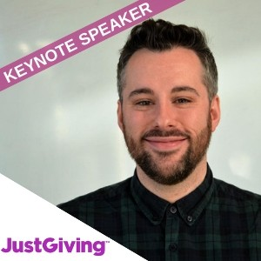
Danny Denhard, Director of Growth - JustGiving

20 Lessons from 20 Years in Marketing

There are so many lessons we fail to learn from, learn from my twenty years in marketing, especially those mistakes so you don’t have to.

……………………………………………………………………………………………………………

Brand & Content
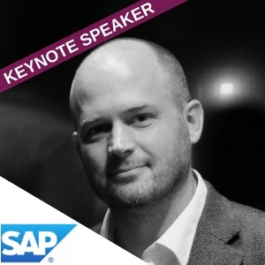
Jack Dyson, Global Head of Content Strategy - SAP Customer Experience

Content that Works: How Journalistic Hacks Can Save B2B Marketers

In this session, you will learn how to squeeze the full value from your content and save your campaigns. Don’t tell stories, sell what you know by creating B2B content that’s bold and brilliant, not bland and boring. Jack will address B2B as a premium purchase, explaining how to make couture content that works, and puts your customers first.

……………………………………………………………………………………………………………

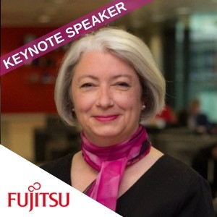
Marketing Strategy
Andrea Clatworthy, Head of ABM - Fujitsu

ABM – What It Is & How to Do It In B2B Services
Fujitsu has been using ABM as a key part of its marketing strategy for several years, with demonstrable results. In this session, learn how they do it, how they integrate with sales, and the pitfalls to avoid.

……………………………………………………………………………………………………………

Your free ticket to the B2B Marketing Expo will also give you unprecedented access to the Marketing Technology Expo, Sales Innovation Expo and Call & Contact Centre Expo; with a combined lineup of 1,000 cutting-edge exhibitors, 500 educational speakers and 200 interactive masterclasses, this is going to be a show like no other.

So what more could you need to succeed? Head over to the website or grab your FREE ticket now, this is THE event to be part of this year.
……………………………………………………………………………………………………………

